

Chapter House Featured in Fall 2015 Arrow

Tucson Alumnae Club



**Pi Beta Phi**

**Tucson Alumnae Club**

**8861 N Majestic Mtn Dr**

**Tucson, AZ 85742**

[**Cass614@gmail.com**](mailto:Cass614@gmail.com)

**LIKE us on Facebook**

**Tucson Alumnae Club of Pi Beta Phi**

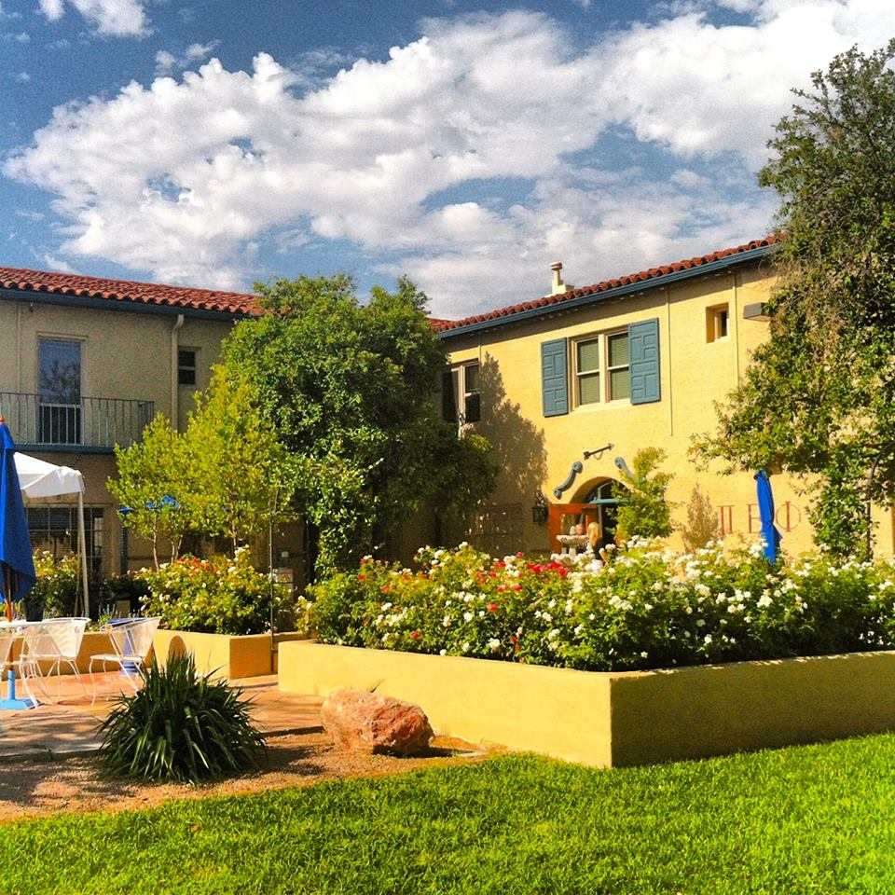

“The beautiful Arizona Alpha Chapter house at the University of Arizona was built in 1929 by famous Swiss American architect Josias Joesler. Throughout the past 86 years, the Chapter House Corporation (currently Kim Rosborough, Deb McGovern, Sharon Carol Reed, Jo Alenson and Brenda Lee) has worked diligently to keep the facility updated, maintained and a place the Arizona Alpha women are proud to call home!

The Arizona Alpha Chapter house sleeps 52 women and can seat 100 women in the dining room. The shabby chic décor is warm and welcoming from the minute you walk through the door.

On the first floor, there is a full kitchen and a small kitchenette. Also on the first floor is a formal living room, a TV room and a study room. Lastly, there is a Heritage Room with historical records and photos of Arizona Alpha’s history.

Upstairs, the women sleep in the sleeping porch, which has 26 sets of bunk beds. Along with two bathrooms, the women study and spend time in 16 day rooms.

Outside, the house is topped off with beautiful landscaping and a fountain, surrounded by outdoor tables and chairs.”

The women can no longer hold their weekly Chapter meetings at the house. With an active chapter of 305, they have outgrown the Heritage Room and the dining room as viable options. Arizona Alpha now rents a hall at the University of Arizona Monday nights to hold Chapter meetings. New member meetings with 110+ new members are held in the dining room Tuesday nights.

However on any given day you will find the dining room full of collegians. They meet there to eat the delicious meals the cooks prepare. The women also work individually and in small groups to prepare for class. The dining room is a good neutral place to have men come over to study.

In addition, the dining room is integral to ceremonies held at the house. Part of recruitment starts in this room and parts of Initiation end there. Cookie shines and much more, with drapes over the windows! If these walls could talk…

*Partially reprinted with permission from Pi Beta Phi

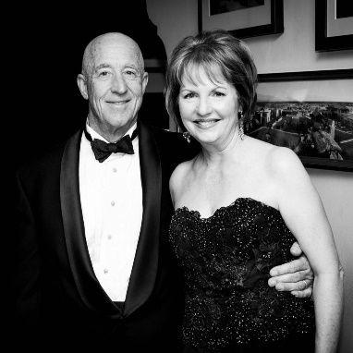

Featured Alumna: Barbara Hall Peck

I am so excited to be communicating with as many alumnae of Arizona Alpha as possible! With Arizona Alpha’s 100th Anniversary coming up in 2017, I wanted to reach out and invite you to return to Tucson in 2017 when we celebrate 100 continuous years of Pi Beta Phi on the campus of the University of Arizona. Toward that goal, we will be sending out a few newsletters to let you know what is going in the Old Pueblo, at the Chapter House and with a few alumnae. Please let me know if you have any suggestions.

Pi Phi Love,

Cass Charles McGinty, President (520) 869-7366 (AZ Alpha 1979)

A Message from the President

***Barb credits her success to family support and a ‘can-do’ attitude***

Barb resides in Tucson with her husband, Hank. She is mother to Shelby and Charlie. Some of you may recall she graduated in 1977 with a degree in nursing. She ended up as a public relations consultant, but her heart is in the desert. Specifically, the Dove of the Desert, Mission San Xavier del Bac. In 2015, Barb was the Silver & Turquoise Ball Chairperson. The Silver & Turquoise Board of Hostesses work each year to support the preservation of Tucson’s cultural heritage and history. The Silver & Turquoise Ball is raising awareness and money for the restoration of the historic Mission San Xavier del Bac founded by Father Eusebio Kino in 1692. Construction of the current church began in 1783 and was completed in 1797. Barb also enjoys spending time with her family in their cabin in the White Mountains.

***Mission San Xavier del Bac was founded by Father Eusebio Kino in 1692. Construction of the current church began in 1783 and was completed in 1797.***

Featured AZ Alpha Collegian: Brenna McGill

Mission Statement, Vision and Core Values

The mission of Pi Beta Phi Fraternity for Women is to promote friendship, develop women of intellect and integrity, cultivate leadership potential and enrich lives through community service.

The vision of Pi Beta Phi Fraternity for Women is to be recognized as a premier organization for women by providing lifelong enrichment to its members and contributing to the betterment of society.

Core Values

* Integrity
* Lifelong Commitment
* Honor and Respect
* Personal and Intellectual Growth
* Philanthropic Service to Others
* Sincere Friendship

***\* * \****

***After Brenna graduated in May 2016, she began working as a Manager for Macy’s Credit and Customer Service Office in Tempe.***

***\* * \****

|  |  |
| --- | --- |
|  | Brenna McGill was crowned the 101st University of Arizona Homecoming Queen on October 23, 2015! Originally from Scottsdale, she was the President of the Arizona Alpha Chapter at the time. Prior to being Pi Beta Phi’s President, Brenna was the Vice President of Administration. Brenna was studying business management in the Eller College of Management and graduated in May, 2016. Brenna was also a member of the Delta Sigma Pi professional business fraternity and was actively involved in the Order of Omega and Rho Lambda Honorary. Brenna attended Pi Phi’s last two Conventions in Chicago and San Diego. Outside of school, Brenna enjoys spending time with friends and family, hiking and volunteering in the Tucson community. After graduation, Brenna began working as a Manager for Macy’s Credit and Customer Service Office in Tempe, AZ. She plans on joining the Phoenix Alumnae Club. |